Problem 1.
Translate into symbols the following statements, using quantifiers, variables, and predicate symbols:
a) A mushroom is poisonous only if it is red.
M(x) – x is a mushroom, P(x) – x is poisonous, R(x) – x is red.
(M(x) ^ P(x)) -> R(x)

b) Not all white mushrooms are poisonous.
M(x) – x is a mushroom, P(x) – x is poisonous, W(x) – x is white.
~(∀x)[(M(x) ^ W(x)) -> P(x)]

c) No woman likes a man who likes all vegetarians.
M(x) - x is man; W(z) – z is a woman; V(z) – z is a vegetarian (all predicates)
[M(x) -> [V(y) -> L(x,y)] -> [W(z) -> ~L(z,x)]
[[M(x) ^ V(y)] -> L(x,y)] -> [W(z) -> ~L(z,x)]

M(x) – x is a man, F(x) – x is a woman /M, F are functors/
[[V(z) -> L(M(x),z)] -> ~L(F(y), M(x))

Problem 2.
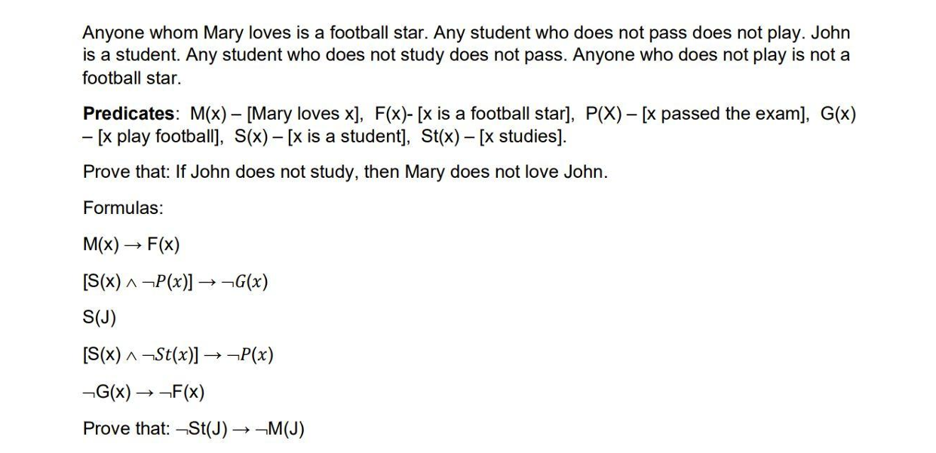

Convert to set of clauses.
KB = {~M(x) v F(x), ~S(x) v P(x) v ~G(x), S(J), ~S(x) v St(x) v ~P(x), G(x) v ~F(x)}
Negation of the goal: ~[St(J) v ~M(J)] = ~St(J) ^ M(J)
KB ∪ {~St(J), M(J)} |- NIL ?

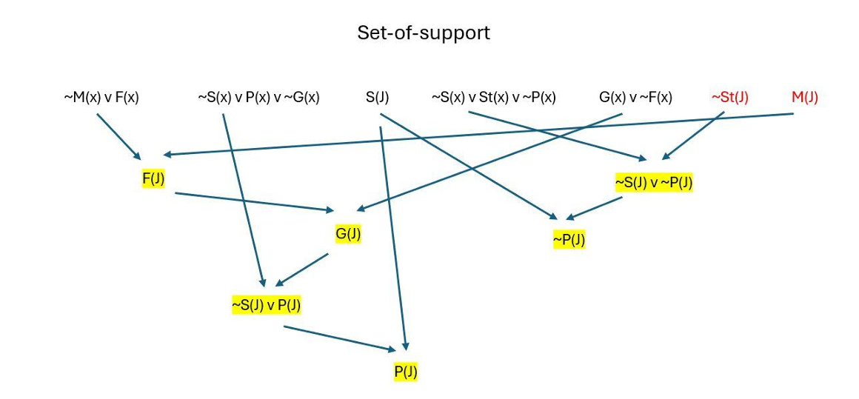

Problem 3.
Consider the following statements:
Every child sees some witch.
It is not true that no witch has both a black cat and a pointed hat.
Every witch is good or bad.
Every child who sees any good witch gets candy.
It is not true that every witch that is bad has a black cat.
If every witch seen by any child has a pointed hat, then every child gets candy.
- Convert them to formulas in Predicate Calculus and then convert your predicate calculus formulas to CNF.
- Form a Knowledge Base containing all obtained disjuncts.

Hint: You can use the following constants, functors, & predicates.
Constants: BC – black cat, PH – pointed hat
Functors: W(x) – x is a witch, C(x) – x is a child
Predicates: SE(x,y) – x sees y, GETS(x) – x gets candy, GOOD(x) – x is good, BAD(x) – x is bad
HAS(x,y) - x has y

Solution:

- (∀x)(∃y)SE(C(x),W(y)) = (∀x)SE(C(x),W(f(x))) = SE(C(x),W(f(x)))
- (∃x)[HAS(W(x),BC) ∧ HAS((W(x), PH)] = [HAS(W(A),BC) ∧ HAS((W(A), PH)], where A is a constant
- GOOD(W(x)) ∨ BAD(W(x))
- [SE(C(x),W(y)) ∧ GOOD(W(y))] →GETS(C(x)) = ¬[SE(C(x),W(y)) ∧ GOOD(W(y))] ∨ GETS(C(x)) =
¬SE(C(x),W(y)) ∨ ¬GOOD(W(y)) ∨ GETS(C(x))
- ¬[BAD(W(x)) → HAS(W(x),BC)] = ¬[¬BAD(W(x)) ∨ HAS(W(x),BC)] = BAD(W(x)) ∧ ¬HAS(W(x),BC)
- (∃x)(∀y)[SE(C(x),W(y)) → HAS(W(Y),PH)] →(∀z)GETS(C(z)) =
¬(∃x)(∀y)[SE(C(x),W(y)) → HAS(W(Y),PH)] ∨ (∀z)GETS(C(z)) =
¬(∃x)(∀y)[¬SE(C(x),W(y)) ∨ HAS(W(Y),PH)] ∨ (∀z)GETS(C(z)) =
[SE(C(x),W(f(x))) ∧ ¬HAS(W(f(x)),PH)] ∨ GETS(C(z)) =
[SE(C(x),W(f(x))) ∨ GETS(C(z))] ∧ [¬HAS(W(f(x)),PH)] ∨ GETS(C(z))]
Knowledge Base:
SE(C(x),W(f(x)))
HAS(W(A),BC)
HAS((W(A), PH)
GOOD(W(x)) ∨ BAD(W(x))
¬SE(C(x),W(y)) ∨ ¬GOOD(W(y)) ∨ GETS(C(x))
BAD(W(x))
¬HAS(W(x),BC)
SE(C(x),W(f(x))) ∨ GETS(C(z))
¬HAS(W(f(x)),PH)] ∨ GETS(C(z))

Problem 4:
Follow RS method to check if (¬a → b) → ((¬b → c) → (¬c → ¬a)) is a tautology.

Solution (Not Tautology).

(¬a → b) → ((¬b → c) → (¬c → ¬a))
¬ (¬a → b), ((¬b → c) → (¬c → ¬a))
¬a, ((¬b → c) → (¬c → ¬a)) ; ¬b, ((¬b → c) → (¬c → ¬a))
¬a, ¬ (¬b → c), (¬c → ¬a)) ; ¬b, ¬ (¬b → c), (¬c → ¬a))
¬a, ¬b, (¬c → ¬a); ¬a, ¬c, (¬c → ¬a); ¬b, ¬b, (¬c → ¬a)); ¬b, ¬c, (¬c → ¬a))
¬a, ¬b, c, ¬a; ¬a, ¬c, c, ¬a ; ¬b, ¬b, c, ¬a ; ¬b, ¬c, c, ¬a
not fundamental fundamental not fundamental fundamental

